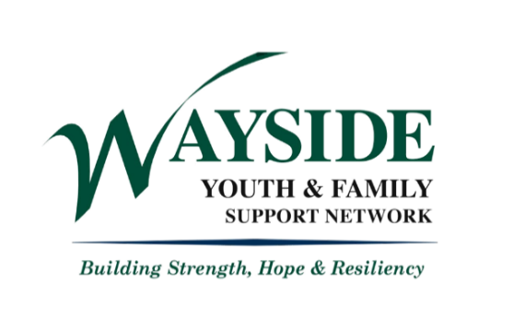

External Referral Form

Name (Parent/Guardian): _______________________________________________________________ DOB: __________
Address: _______________________________________________________________________________________________________
Phone: ____________________________________________ Email: ___________________________________________________
Primary Language: _____________________________ Referral Source: _______________________________________
Does the family have transportation? YES NO

Reason(s) for Referral (check all that apply):
School Issue/School Info |  |  | Housing/Rent
Child Care Info |  |  | Transportation
Afterschool Info |  |  | Job Issues
Substance Abuse Concerns |  |  | Continuing Education for Caregiver
Health/Mental Health Concerns |  |  | Immigration/Legal Issues
Family Hardship/Financial Issues |  |  | Other: _________________________________

Additional Notes: ___________________________________________________________________________________________________________________________________________________________________________________________________________________________________________________________________________________________________________________________
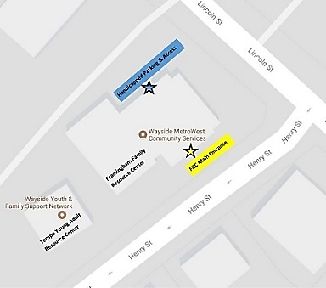

Wayside Youth & Family Support Network
Framingham Family Resource Center
88 Lincoln Street
Framingham, MA 01702
Main: 508.270.1313
Fax: 508.626.7625

~ www.waysideyouth.org/FamilyResourceCenter ~

